**SQL CHEATCODE --refer datalemur and practice nice amount of questions  
check for extract and to char fn**

MySQL powers many of the most accessed applications, including Facebook, Twitter, Netflix, Uber, Airbnb, Shopify, and Booking.com.

Ddl commands: create, alter, drop, truncate  
  
CREATE TABLE SCHOOL(  
 SCHOOL_CODE INT NOT NULL,  
 SCHOOL_NAME VARCHAR(500),  
 ADDRESS VARCAHR(500),  
 PHONE_NUMBER INT,  
 STARS INT,  
 AGE INT,  
 PRIMARY KEY (SCHOOL_CODE)  
);

ALTER TABLE SCHOOL ADD CITY VARCHAR(100); -- adding column in existing table

ALTER TABLE SCHOOL DROP AGE; -- drop the column from existing table

ALTER TABLE SCHOOL RENAME STARS TO RATING; --renaming column name

ALTER TABLE SCHOOL MODIFY COLUMN SCHOOL_CODE VARCHAR(10);

DROP TABLE SCHOOL;

TRUNCATE TABLE SCHOOL;

CREATE TABLE TEACHERS(  
 STAFF_ID INT NOT NULL PRIMARY KEY,  
 STAFF_NAME VARCHAR(50),  
 SPEACIAL_ACTIVITY VARCHAR(50),  
 SCHOOL_CODE VARCHAR(10) FOREIGN KEY REFERENCES SCHOOL(SCHOOL_CODE)  
);  
  
CREATE TABLE CULTURAL_ACTIVITY(  
 SERIAL_NO INT AUTO_INCREMENT,  
 ACTIVITY UNIQUE NOT NULL,  
 CATEGORY VARCHAR(20) CHECK(CATEGORY IN (‘ENTERTAINMENT’,’SPORTS’)  
);

CREATE TABLE NEW_STUDENT(  
 STUDENT_ID VARCAHAR(20) PRIMARY KEY,  
 NAME VARCHAR(200),  
 ACTIVITY_PARTICIPATED VARCHAR(200),  
 ACHIEVEMENT_TAB VARCHAR(20),  
 SCHOOL_CODE VARCHAR(10) FOREIGN KEY REFERENCES SCHOOL(SCHOOL_CODE),  
 COACH_ID VARCHAR(10) FOREIDN KEY REFERENCES TEACHERS(STAFF_ID)  
);

DML commands : Insert,update,delete, merge  
INSERT INTO SCHOOL (SCHOOL_CODE,SCHOOL_NAME,ADDRESS,PHONE_  
NUMBER,RATING) VALUES (‘HS394’,’ TMHNU.Mat.Hr.Sec.School’,’ KMC Nagar,Theni’, 9943565608,3);  
INSERT INTO SCHOOL (SCHOOL_CODE,SCHOOL_NAME,ADDRESS,PHONE_  
NUMBER,RATING) VALUES(‘SS762’,’ VSJR.Sec.School’,’ Lakshmi Housing Street, Karur’, 8344524956, 5);  
INSERT INTO SCHOOL (SCHOOL_CODE,SCHOOL_NAME,ADDRESS,PHONE_  
NUMBER,RATING) VALUES(‘HS994’,’Meenakshi.Govt.Hr.Sec.School’,’ Samudhaya Aram Street, Vellore’ , 9876768239,4);  
INSERT INTO SCHOOL (SCHOOL_CODE,SCHOOL_NAME,ADDRESS,PHONE_  
NUMBER,RATING) VALUES(‘SS834’,’ KCT.Sec.School’,’ Saravanampatti,Cbe’,7890654312,2);  
INSERT INTO SCHOOL (SCHOOL_CODE,SCHOOL_NAME,ADDRESS,PHONE_  
NUMBER,RATING) VALUES(‘SS882’,’ Kgsil.Public.Sec.School’,’ Keeranatham, Cbe’, 6584768323,’’);  
INSERT INTO SCHOOL (SCHOOL_CODE,SCHOOL_NAME,ADDRESS,PHONE_  
NUMBER,RATING) VALUES(‘HS950’,’ Ruby Mat.Hr.Sec.School’,’ Vikas Avenue, Madurai’, 6380464655,5)  
---  
  
DELETE FROM GFG_Employees WHERE NAME = 'Rithvik'

CREATE TABLE NEW_TABLE AS SELECT * FROM SCHOOL  
OR   
CREATE TABLE NEW_SCHOOL_DATA AS SELECT SCHOOL_CODE,SCHOOL_NAME FROM SCHOOL  
WHERE COUNTRY =’  
OR   
SELECT * INTO NEW_TABLE FROM OLD_TABLE

UPDATE SCHOOL  
SET SCHOOL_NAME =’w3schools’  
where school_code =’HS200’;

Coalesce and ifnull

For eg arg1= null, arg2 = 15, arg3 =13   
both does similar function but in coalesce it gives 1st not null value  
in if null it deals with only two values

Merge performs operation like insert, update and delete together  
 It need to have source table and target table. In source table updated table or list will be there whereas in target table where the changes need to be implemented

merge syntax:

Merge demo:

Target table  
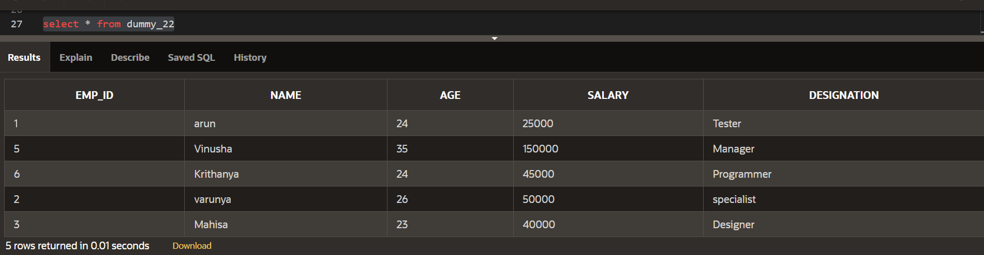

Source table

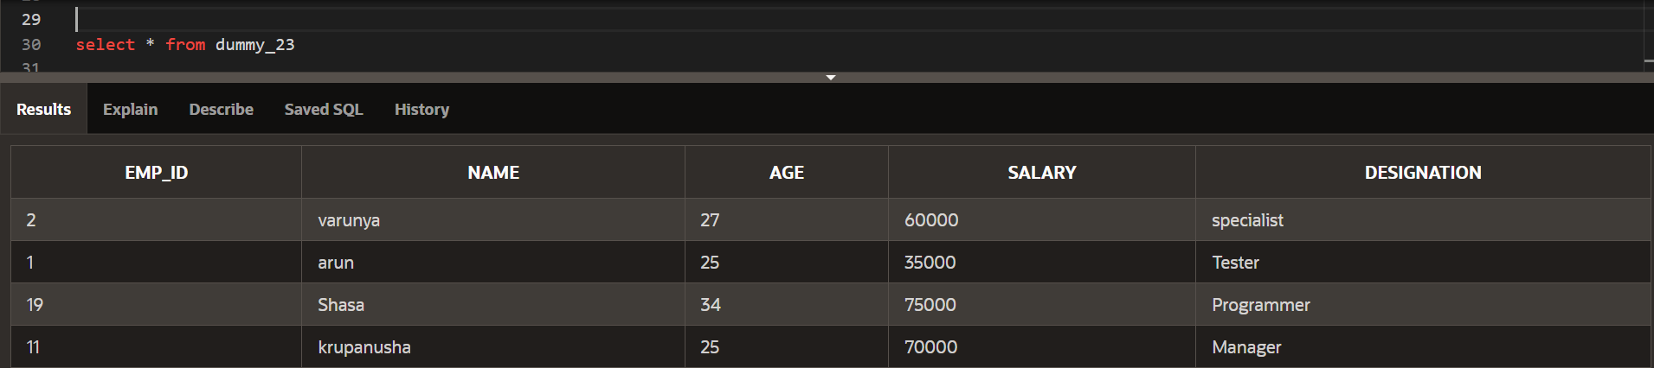

merge into dummy_22 t   
using dummy_23 s  
on (t.emp_id = s.emp_id)  
when matched then   
 update set t.age = s.age, t.salary = s.salary  
when not matched then  
 insert(t.emp_id,t.name,t.age,t.salary,t.designation) values(s.emp_id,s.name,s.age,s.salary,s.designation)  
when not matched by source then   
 delete;

-------------------count filter clause-----------------

SELECT

COUNT(*) FILTER (WHERE conditional_expression)

FROM table_name;

example

SELECT

COUNT(*) FILTER (WHERE device_type = 'laptop') AS laptop_views,

COUNT(*) FILTER (WHERE device_type IN ('tablet', 'phone')) AS mobile_views

FROM viewership;

Sql general codes:  
   
select review_id, submit_id, stars  
from reviews  
where stars < 4 and review_id%2=0  
--------------  
SELECT * FROM reviews

WHERE NOT rating = 5;  
---------------

SELECT * FROM reviews

WHERE stars NOT BETWEEN 2 AND 4;  
---------------------  
SELECT drug, manufacturer, units_sold

FROM pharmacy_sales

WHERE manufacturer IN ('Biogen', 'Bayer', 'Eli Lilly');  
-------------------------  
select product_id, drug from pharmacy_sales  
where drug like ‘%relief%’  
Arithmetic functions: it deals with symbols like +,-,*,/

Where math functions are floor,ceil,round,abs,trunc  
floor- round down, ceil – round up, abs – it will give difference value without - symbol  
trunc – it will not roundup the value  
:: - this notation denotes to type cast

SELECT

character,

superhero_alias,

platform,

CASE

WHEN followers >= 500000 THEN 'Popular'

END AS popularity_category

FROM marvel_avengers;

-----Joins------  
SELECT

orders.order_id,

deliveries.delivery_id,

deliveries.delivery_date,

deliveries.delivery_status

FROM orders

LEFT JOIN deliveries

ON orders.order_id = deliveries.order_id;

----Date function-----------  
SELECT  
 message_id,   
 sent_date,  
 EXTRACT(YEAR FROM sent_date) AS extracted_year,  
 DATE_PART('year', sent_date) AS part_year,  
from messages

the art of dealing people